**Project Report**

* **Insight-1:** **Which categories have the maximum count of outcome?**

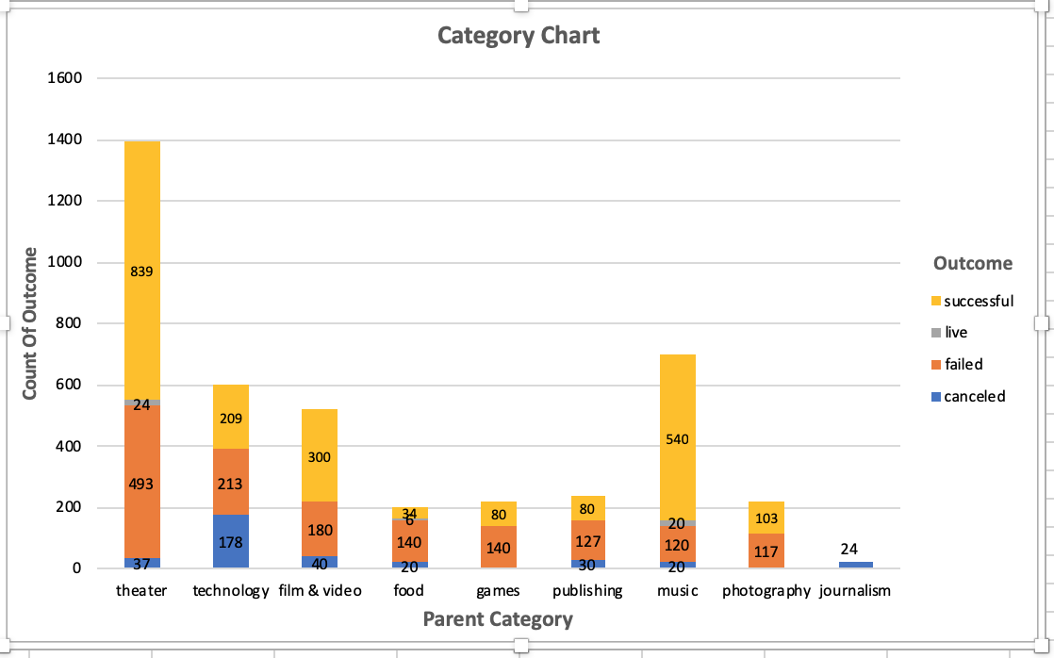

From this bar chart , we can see that **theatre** and **music** are the two categories which have the maximum count of outcome. In the below table we can see that theatre **“plays”** have the maximum no of **successful** outcome count as well as the **failure** outcome count as compared to the other categories.

**Theatre:**

|  |  |  |  |  |  |
| --- | --- | --- | --- | --- | --- |
|  | **Theatre** | **cancelled** | **Failed** | **Live** | **Successful** |
| **1** | **Musical** | **20** | **60** |  | **60** |
| **2** | **Plays** |  | **353** | **19** | **694** |
| **3** | **Spaces** | **17** | **80** | **5** | **85** |

In Music category, **“rock”** music has the maximum no of **successful** outcome.

**Music:**

|  |  |  |  |  |  |
| --- | --- | --- | --- | --- | --- |
|  | **Music** | **cancelled** | **Failed** | **Live** | **Successful** |
| **1** | **classical music** |  |  |  | **40** |
| **2** | **electronic music** |  |  |  | **40** |
| **3** | **faith** |  | **40** | **20** |  |
| **4** | **indie rock** |  | **20** |  | **140** |
| **5** | **jazz** |  | **60** |  |  |
| **6** | **metal** |  |  |  | **20** |
| **7** | **pop** |  |  |  | **40** |
| **8** | **rock** |  |  |  | **260** |
| **9** | **world music** | **20** |  |  |  |

* **Insight-2:** **Which sub-category required the maximum no of conversion days?**

With the help of the “**date created conversion**” and “**date ended conversion**” columns we can calculate the “**conversion days**” required by each category.

The count of conversion days is high for **“Technology”, ”music” &“theatre”(category)**. In the below bar chart, we can see that the ”**plays**” sub-category (theatre category) has taken the maximum no of conversion days.

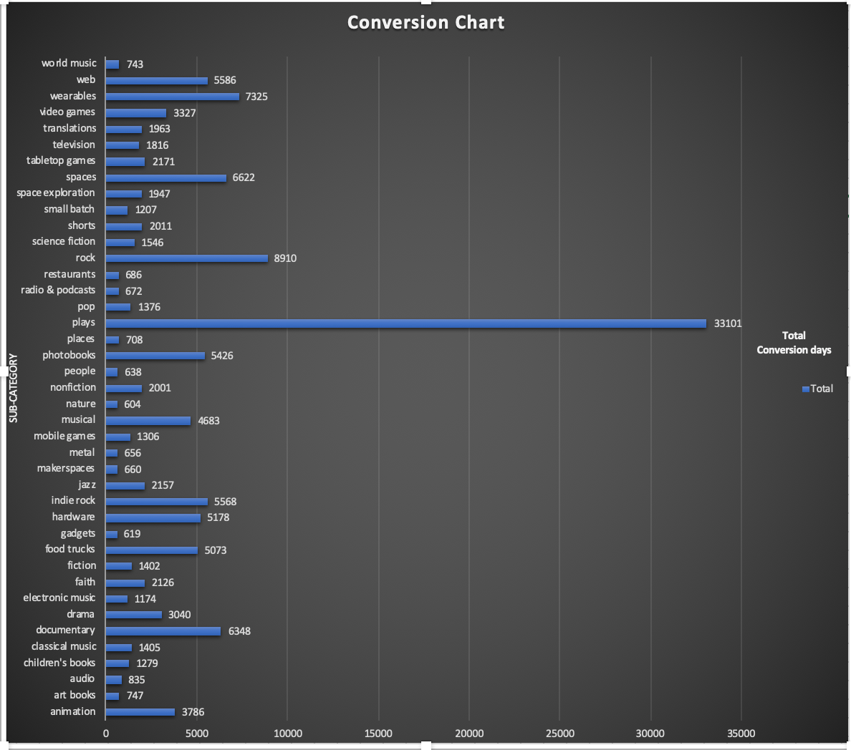

* **Insight-3:** How is the total pledge amount distributed across different categories?

In the below pie chart, we can see that “**Technology**” category has the highest pledge amount percentage rate. Along with this 12% rate is covered by both “**theatre”** and “**Film & video**” categories.

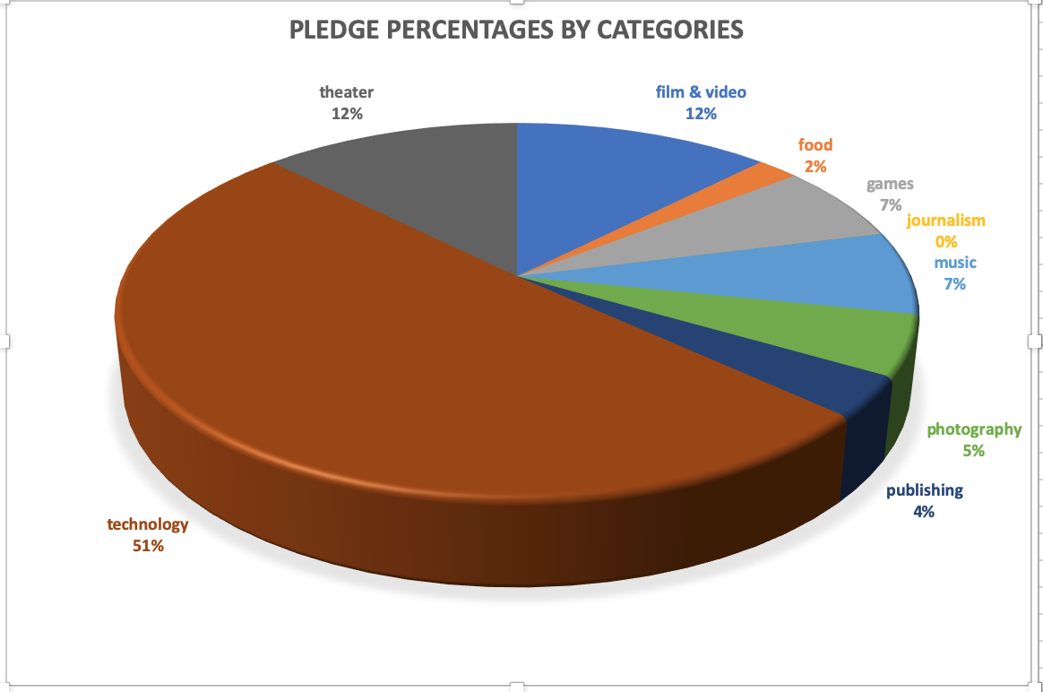

The below image shows the relationship between the “**sum of goal**” and “**sum of pledge**” across the different categories.

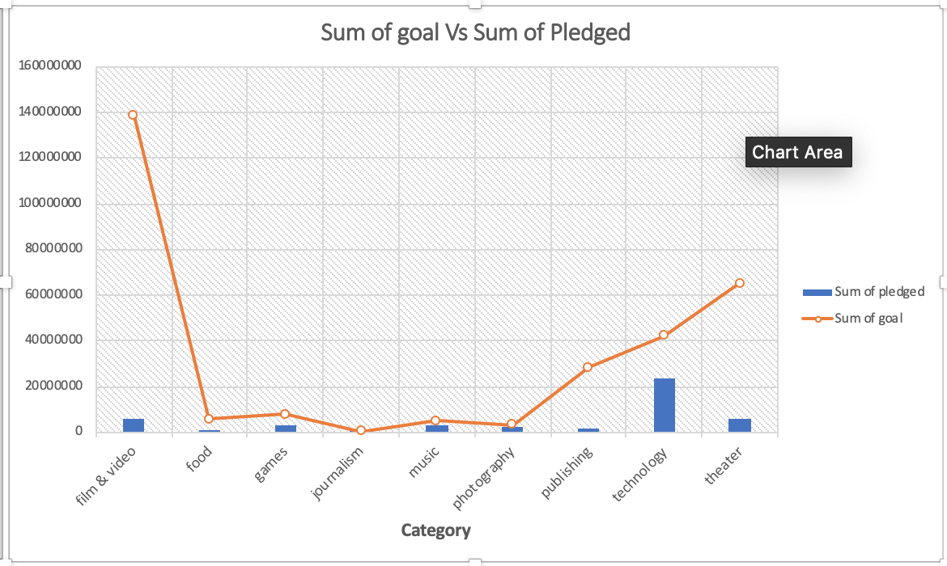

**Limitations of dataset:**

* Lack of substantial detail parts of the data.
* The columns name “**currency**”, “**Staff-pick**”, “**spotlight**” did not help to pull more information from the data.
* More information about the “**backers**” would have added the little exposure to the discovery.

**Conclusions:**

* **Theatre** and **music** are the two categories which have the maximum **count of outcome.**
* It took more no. of days to complete the goals for **“Technology”, ”music” &“theatre”(category)**.
* “**Technology**” category has the highest **pledge amount** percentage rate.
* Outcome based on the goal:

**71%** of outcome are “**successful**” for **less than 1000** goal amounts.

**58%** of outcome are “**failed**” for **more than 50000** goal amounts.

**23%** of outcome are “**canceled**” for **more than 50000** goal amounts.